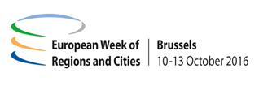

Opening Session European Week of Regions and Cities 2016
Cohesion Policy investing in Europe's regions and cities
10 October 2016, 14:30-16:30, EP Hemicycle

14.30 – 14.45 Introduction and welcome by moderator Karen Coleman, journalist
14.45 – 15.15 Opening statements
Ramón Luis Valcárcel Siso, Vice-President of the European Parliament Corina Crețu, European Commissioner for Regional Policy
Markku Markkula, President of the European Committee of the Regions Anton Marcinčin, Plenipotentiary of the Slovak government for support of least developed regions
15.20 – 16.00 DEBATE: Cohesion policy at work - Experiences from the ground and expectations
16.05 – 16.25 DEBATE: Cities as engine for growth and job opportunities
16.25 – 16.30 Closing remarks

Interpretation will be provided in 23 languages
www.regions-and-cities.europa.eu
#EUWRC

